Book

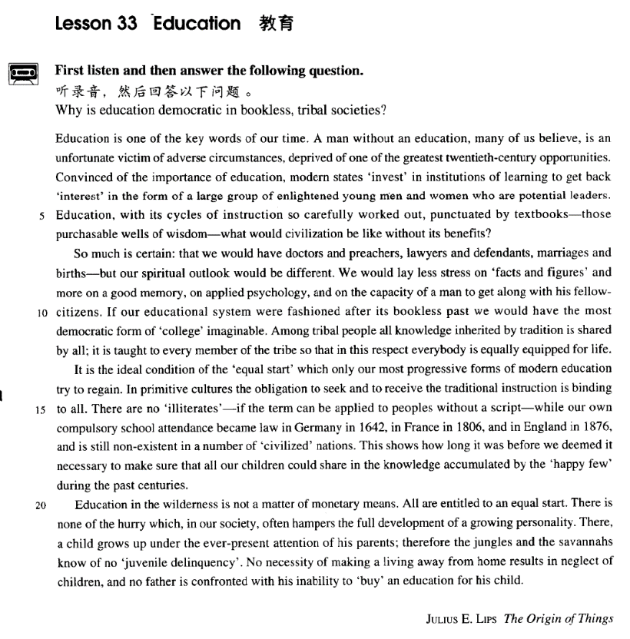

课文

Education is one of the key words of our time.

教育是我们这个时代的关键词之一。

A man without an education, many of us believe, is an unfortunate victim of adverse circumstances, deprived of one of the greatest 20th-century opportunities.

我们许多人都相信，一个没有受过教育的人，是逆境的牺牲品，被剥夺了20世纪的最优越的机会之一。

Convinced of the importance of education, modern states 'invest' in institutions of learning to get back 'interest' in the form of a large group of enlightened young men and women who are potential leaders.

现代国家深深懂得教育的重要性，对教育机构投资，收回的‘利息’便是培养出大批有知识的男女青年，这些人可能成为未来的栋梁。

Education, with its cycles of instruction so carefully worked out, punctuated by textbooks -- those purchasable wells of wisdom -- what would civilization be like without its benefits?

教育，以其教学周期如此精心地安排，并以教科书 -- 那些可以买到的智慧源泉 -- 予以强化，如果不受其惠，文明将会是个什么样子呢？

So much is certain: that we would have doctors and preachers, lawyers and defendants marriages and births -- but our spiritual outlook would be different.

至少，这些是可以肯定的：虽然我们还会有医生和牧师、律师和被告、婚姻和生育，但人们的精神面貌将是另一个样子。

We would lay less stress on 'facts and figures' and more on a good memory, on applied psychology, and on the capacity of a man to get along with his fellow-citizens.

人们不会重视‘资料和数据’，而靠好记性、实用心理学与同伴相处的能力。

If our educational system were fashioned after its bookless past we would have the most democratic form of 'college' imaginable.

如果我们的教育制度仿效没有书籍的古代教育，我们的学院将具有可以想象得出的最民主的形式了。

Among tribal people all knowledge inherited by tradition is shared by all;

在部落中，通过传统继承的知识为所有人共享，并传授给部落中的每一个成员。

it is taught to every member of the tribe so that in this respect everybody is equally equipped for life.

从这个意义上讲，人人受到的有关生活本领的教育是相等的。

It is the ideal condition of the 'equal start' which only our most progressive forms of modern education try to regain.

这就是我们最进步的现代教育试图恢复的“平等起步”的理想状况。

In primitive cultures the obligation to seek and to receive the traditional instruction is binding to all.

在原始文化中，寻求和接受传统教育的义务对全民都有约束力。

There are no'illiterates' -- if the term can be applied to peoples without a script -- while our own compulsory school attendance became law in Germany in 1642, in France in 1806, and in England in 1876 and is still nonexistent in a number of 'civilized' nations.

因而没有“文盲”（如果这个字眼儿可以用于没有文字的民族的话）。而我们的义务教育成为法律在德国是在1642年，在法国是在1806年，在英国是在1876年。

This shows how long it was before we deemed it necessary to make sure that all our children could share in the knowledge accumulated by the 'happy few' during the past centuries.

这说明，经过了多么漫长的时间之后，我们才认识到，有必要确保我们的孩子享有多少个世纪以来由‘少数幸运者’所积累起来的知识。

Education in the wilderness is not a matter of monetary means.

荒凉地区的教育不是钱的问题，

All are entitled to an equal start.

所有的人都享有平等起步的权利。

There is none of the hurry which, in our society, often hampers the full development of a growing personality.

那里没有我们今天社会中的匆忙生活，而匆忙的生活常常妨碍个性的全面发展。

There, a child grows up under the everpresent attention of his parents;

荒凉地区的孩子无时无刻不在父母关怀下成长。

therefore the jungles and the savannahs know of no 'juvenile delinquency'.

因此，丛林和荒凉地区不知道什么叫“青少年犯罪”。

No necessity of making a living away from home results in neglect of children, and no father is confronted with his inability to 'buy' an education for his child.

人们没有必要离家谋生，所以不会产生孩子无人管的问题，也不存在父亲无力为孩子支付教育费用而犯难的问题。

词汇讲解

Lesson 33 Education

adverse ['ædvɜ:s]

adj. 不利的，不好的

adverse effects

adverse weather conditions adverse circumstances adverse wind

adversity / misfortune

in the face of adversity

We struggled on in the face of adversity. adversary opponent

antagonist unfavorable

unfavorable circumstances hostile

hostile climatic conditions detrimental

Overexposure to sunlight can have a detrimental effect on the skin. preacher ['pri:tʃə(r)]

n. 布道的人，传教士

preach sermon

The Prime Minister was trying to preach peace and tolerance to his people.

advocate He advocates the return of capital punishment.

defendant [dɪ'fendənt]

n. 被告人

defendant plaintiff

prosecutor prosecute sb.

|  |  |  |
| --- | --- | --- |
| judge | witness | jury |
| attorney |  | solicitor |
| barrister |  | lawyer |
| testimony |  | affidavit |
| outlook ['aʊtlʊk] |  |  |

n. 总的态度，观点；展望，前景

outlook *on* life world outlook

communist world outlook spiritual / mental outlook attitude *to / towards* sth. perspective *on* …

from sb’s perspective √ from sb’s viewpoint √ from sb’s standpoint √

from sb’s point of view √ in sb.’s opinion / view √ according to sb. √

from sb.’s opinion / view X according to sb.’s opinion / view X according to me X

The outlook *for* the economy is still uncertain. The outlook *for* tomorrow is sunny and mild. prospect

The prospects *for* employment in the technology sector are especially good.

capacity [kə'pæsəti]

n. 容量，承受量；能力

The auditorium has a seating capacity *of* 2,000. The elevator has a capacity *of* 1,000 kilos.

the capacity *to* read and write

He has enormous capacity *for* work. ability to do sth.

capability to do sth. capability of doing sth.

gift talent aptitude faculty democratic [7demə'krætɪk]

adj. 民主的democratic rights democratic elections

a democratic government the Democratic Party

democracy democrat

republican republic

monarchy monarch

constitutional monarchy

autocracy autocratic

autocrat

compulsory [kəm'pʌlsəri]

adj. 有义务的，必须做的

a compulsory course

an elective / optional course

the 9-year compulsory education / schooling / school attendance

compel sb. to do

President Nixon was compelled to resign. compulsive

compulsive gambling

a compulsive gambler / liar

compelling

a compelling novel / story

oblige sb. to do obligatory

an obligatory course obligatory military service voluntary

voluntary donations voluntary early retirement hamper ['hæmpə(r)]

v. 妨碍

hamper / hinder / impede

Social unrest will ~ economic development. Higher interest rates could ~ economic growth. hindrance / impediment

The higher rates have been a hindrance *to* economic recovery. The main impediment *to* growth was a lack of capital.

a key word / issue / factor

Development is one of the key words of our time. vital crucial essential critical We're at a critical time in our history.

momentous

a momentous decision / occasion

be of paramount importance to …

Passenger safety is of paramount importance to us. be uppermost in one’s mind

Although I’m here in Beijing, my family back in my hometown is always uppermost in my mind.

A man without an education, *many of us believe*, is an unfortunate victim of adverse circumstances, deprived of one of the greatest twentieth-century opportunities.

A man is a victim.

Many of us believe that a man without an education is an unfortunate victim of …

A man without an education, many of us believe, is an unfortunate victim of …

You may wonder why spiders are our friends.

Why, you may wonder, should spiders be our friends? It seems that dogs love to chew up money!

Dogs, it seems, love to chew up money!

Many of us believe that economic development is of paramount importance to china.

Economic development, many of us believe, is of paramount importance to china.

Convinced of the importance of education, modern states 'invest' in institutions of learning *to get back 'interest' in the form of a large group of enlightened young men and women who are potential leaders.* convince sb. of sth.

be convinced of … invest in …

invest … in …

I invested time and energy in learning English. invest … with …

invest sb. with legal rights

His life was invested with a new significance.

… nor should we seek to invest with significance that which we cannot grasp.

financial / educational / charitable institution institute

the institute for the destitute agricultural / aviation institute

MIT: Massachusetts Institute of Technology

enlightened adj. free from prejudice, ignorance, superstition, etc. 开明的

enlightened attitude / policy

enlighten

Education, with its cycles of instruction so carefully worked out, *punctuated by textbooks —those purchasable wells of wisdom—*what would civilization be like without its benefits?

work out 制定出，策划出

work out a plan / program

punctuate

punctuate the article

a speech punctuated by applause

He made gestures to punctuate his remarks. emphasize / stress …

lay / put emphasis / stress on …

Schools here lay / put great emphasis on mathematics.

In his speech, he laid / put particular stress on the freedom of the press.

We would lay less stress on 'facts and figures' and more on a good memory, on applied psychology, and on the capacity of a man to get along with his fellow-citizens.

A science reporter, he has a wide range of knowledge. Bank loan or no bank loan, we’ll buy the house.

Master in his own house, he has little idea of when to say boo to a maître d'hôtel.

What would civilization be like if there were not its benefits?

If + S. + did / were …, S. + would / should / could / might + do … Without it we could not make a living.

If we didn’t have it we could not make a living. There would be no living things without air.

There would be no living things if there were no air. In his position, I would commit suicide.

If I were in his position, I would commit suicide. How would civilization be without its benefits?

Education, what would civilization be like without its benefits? God Almighty, where are you when the world is racked by war?

造句：影响遍及全球，并且被广泛的应用 (a wide range of applications)

所强化的因特网技术，如果没有它带来的好处的话，我们的生活将会是什么样子呢？

Internet technology, with its influence spreading to every corner of the world, punctuated by a wide range of applications, what would our lives be like without its benefits?

So much is certain: that we *would* have doctors and preachers, lawyers and defendants, marriages and births—but our spiritual outlook *would* be different.

We *would* lay less stress on 'facts and figures' and more on a good memory, on applied psychology, and on the capacity of a man *to get*

*along with his fellow citizens*.

We would lay less stress *on* 'facts and figures' and (lay) more (stress) *on* a good memory, (lay more stress) *on* applied psychology, and (lay more stress) *on* the capacity of a man to get along with his fellow-citizens.

It has been said that everyone lives by selling something. In the light of this statement, teachers live *by* selling knowledge, philosophers (live) *by* selling wisdom and priests (live) *by* selling spiritual comfort.

Carlyle was entirely ignorant *of* what the bottle in his pocket contained, (Carlyle was entirely ignorant) *of* the nature of the illness from which his friend was suffering, and (Carlyle was entirely ignorant) *of* what had previously been wrong with his wife, but a medicine …

For in a university, science majors look down *on* humanities majors, foreign language majors (look down) *on* Chinese majors, Chinese

majors (look down) *on* philosophy majors, philosophy majors (look down) *on* sociology majors, and sociology majors (look down) *on*

education majors. Since education majors have no one to look down on, they can only despise the professors in their own department.

attach importance to …

We would attach less importance *to* 'facts and figures' and more *to* a good memory, *to* applied psychology, and *to* the capacity of a man to get along with his fellow-citizens.

If our educational system *were* fashioned after its bookless past we *would*

have the most democratic form of 'college' imaginable. fashion

He fashioned a toy gun from a piece of wood. fashion … after …

If you fashion your character after your brother’s, you’ll get along with your classmates.

He has to deduce what he can from the few scanty clues available. the most civilized society imaginable

the most shocking spectacle conceivable

the most effectual measure possible

the most talented person available

*Among tribal people* all knowledge inherited by tradition is shared by all;

it is taught to every member of the tribe so that in this respect everybody is equally equipped for life.

In some moods, nature shares it. share sth. with sb.

share (in) sth.

She shares (in) my troubles as well as my joys.

This shows how long it was before we deemed it necessary to make sure that all our children could share in the knowledge accumulated by the 'happy few' during the past centuries.

in this respect

in this aspect

in this way

from this angle

from this perspective

equality in terms of receiving knowledge

It is the ideal condition of the 'equal start' which only our most progressive forms of modern education try to regain.

progressive

a progressive political party progressive ideas aggressive

regressive

regain recover restore one’s health

regain one’s sight

restore one’s consciousness

recover one’s balance

one’s composure

In primitive cultures the obligation *to seek and to receive the traditional*

*instruction* is binding to all. have an obligation to do sth.

be under an obligation to do sth. have no obligation to do sth.

be under no obligation to do sth.

be not under any obligation to do sth.

The firm has no obligation / is under no obligation / isn’t under any

obligation to offer you a job. binding

a legally binding document bind

The thief is bound to a tree. bind sb. to do sth.

The Kyoto Protocol binds each country to reduce the emission of greenhouse gases.

There are no 'illiterates'—if the term can be applied to peoples without a script—while our own compulsory school attendance became law *in*

*Germany in 1642*, *in France in 1806*, and *in England in 1876*, and is still non-existent *in a number of 'civilized' nations*.

script

Arab script

compulsory school attendance / education / schooling

This shows how long it was *before we deemed it necessary to make sure*

*[that all our children could share in the knowledge (accumulated by the*

*'happy few' during the past centuries)]*.

It will be a long time before we meet again.

Looking at his watch, he saw that it was one o'clock, but the bell struck thirteen times before it stopped.

I hadn’t waited long before he came. I shaved before I went to the party.

Alfred stayed in the camp a week before he returned to Athelney. I’ll die before I give in.

…, and these will ply the short wings with such irresistible power that they can bore for long distances through an opposing gale before

exhaustion follows.

The plane had been planting seed for nearly a month when it began to rain.

He had travelled only seven miles across the Channel when his engine failed and he was forced to land on the sea.

Shrugging my shoulders, I began to walk away when, a moment later, he ran after me and thrust the pen into my hands.

Stone does not decay, and so the tools of long ago have remained when even the bones of the men who made them have disappeared without trace.

Why do you walk when you have a car? the few

A government should serve the many, not the few. the happy few

the privileged few

The 19th Amendment to the Constitution of the US shows how long it was before the Americans deemed it necessary to make sure that women could share in the right to vote taken by the privileged few during the past few centuries.

a / the matter / question of …

……的事儿/问题

It’s only a matter of time.

It’s a matter of personal taste. It’s a matter of preference.

It’s a matter of interest.

It’s a matter of life and death.

I can’t take the money. It’s a matter of principle.

… it looks very much as if sleeping is not simply a matter of giving the body a rest.

These are partly a matter of personal circumstances, partly a matter of psychology.

a question of pride

She is so talented that her success is only a question of time.

… but as soon as the question of prestige arises, … monetary policy

monetary unit

be entitled to sth.

be entitled to do sth.

All are entitled to receive equal education.

There is none of the hurry which, in our society, often hampers the full development of a growing personality.

There, a child grows up *under the ever-present attention of his parents*;

therefore the jungles and the savannahs know of no 'juvenile delinquency'.

the ever-present threat

We have to ask ourselves very seriously what will happen if this twofold use of knowledge, with its *ever-increasing* power, continues.

the ever-changing world

the ever-growing knowledge the ever-developing economy the ever-expanding market the ever-deepening reform the ever-dwindling resources the concrete jungle

the law of the jungle know of / about

learn of / about

hear of / about

Verrazano, an Italian about whom little is known, sailed into New York Harbour in 1524 and named it Angouleme.

The 1980s witnessed enormous growth in the financial sector. A gentle breeze caressed my cheeks and soothed my heart.

No necessity *of making a living away from home* results in neglect of

children, and no father is confronted with his inability *to 'buy' an*

*education for his child*. No money buys health.

No two sorts of birds practise quite the same sort of flight; the varieties are infinite; but two classes may be roughly seen.

be confronted / faced with …